LANGUAGE IDENTIFICATION SYSTEM FOR KENYAN LANGUAGES

Name: Gitari Collins Munene

Course: CSC423: Special Topics - DL

Institution: Africa Nazarene University

Lecturer: Prof. Jonah Marwa

Table of Contents
INTRODUCTION 3
PROBLEM STATEMENT 3
OBJECTIVES 4
DATASET 4
DATA PREPROCESSING 4
FEATURE EXTRACTION 5
MODEL TRAINING 5
MODEL EVALUATION 6
SYSTEM IMPLEMENTATION 7
CODE STRUCTURE EXPLANATION 8
DEPLOYMENT (BONUS) 8
HANDLING MIXED LANGUAGE (BONUS) 9
RESULTS 9
Test Cases 10
CONCLUSION 11
FUTURE WORK 11
Limitations 11
Dataset References 12
• Social Media Platforms: 12
• Online Articles: 12
• SMS/Text Communication: 12
• Public Language Datasets: 12
• Transcribed Speech: 12

INTRODUCTION
Language identification is a key task in Natural Language Processing that involves automatically determining the language of a given text. It is widely used in applications such as machine translation, chatbots, search engines, and social media analysis.

In multilingual societies such as Kenya, communication involves multiple languages including English, Swahili, Kikuyu, and Sheng. Additionally, users frequently mix languages within a single sentence, making language identification more complex.

This project focuses on developing a machine learning based language identification system capable of accurately detecting the language of short text inputs, including mixed-language text.

PROBLEM STATEMENT
Most existing language identification systems are designed for formal text and struggle with informal language, slang, and code-mixed text.
In Kenya, Sheng and mixed-language communication are very common, especially in social media and daily conversations. This makes it difficult for traditional models to correctly classify text.
The problem addressed in this project is to build a system that can accurately identify languages in such real-world scenarios, including handling mixed-language input.

OBJECTIVES
The main objectives of this project are:
- To develop a language identification system using machine learning techniques
- To support multiple languages including English, Swahili, Kikuyu, and Sheng
- To handle mixed-language text
- To evaluate the performance of different machine learning models
- To deploy the system as an interactive web application

DATASET
Data Sources
The dataset was created using a combination of manually generated sentences and real world language patterns inspired by:

- Social media conversations
- Online articles
- SMS/text communication styles
- Everyday spoken language

These sources were used as references to ensure the dataset reflects real-world usage, especially for Sheng and mixed-language communication.

DATA PREPROCESSING
Data preprocessing is an important step in NLP to clean and standardize text before training models.
The following preprocessing steps were applied:

- Conversion of text to lowercase to ensure uniformity
- Removal of punctuation and special characters
- Removal of extra spaces
- Tokenization
- Normalization of Sheng slang terms
- Simplification of Kikuyu text to remove complex characters

These steps help reduce noise and improve the performance of machine learning models.

FEATURE EXTRACTION
To convert text into numerical form, several feature extraction techniques were used:

- Bag of Words: Represents text as word frequency counts
- TF-IDF (Term Frequency-Inverse Document Frequency): Weighs words based on importance
- Character n-grams: Captures sequences of characters

Character n-grams were found to be highly effective for language identification because they capture patterns specific to each language.

MODEL TRAINING
Two machine learning models were trained:

• Naïve Bayes
• Logistic Regression

The dataset was split into training and testing sets using an 80/20 ratio.

Naïve Bayes is a probabilistic classifier that works well for text classification tasks.

Logistic Regression is a linear model that provides high accuracy and is widely used in classification problems.

MODEL EVALUATION
The models were evaluated using the following metrics:

- Accuracy
- Precision
- Recall
- F1-score
- Confusion Matrix

Analysis showed that both models performed very well, with Logistic Regression achieving perfect accuracy on the test data.

Logistic Regression performed slightly better than Naïve Bayes due to its ability to model relationships between features, while Naïve Bayes assumes independence.

SYSTEM IMPLEMENTATION
The system was implemented using Python and various libraries including:

- Pandas for data handling
- Scikit-learn for machine learning
- Streamlit for building the user interface

The system takes user input, processes the text, converts it into features, and predicts the language using the trained model.
-System architecture showing the flow from input text to language prediction.
Feature Extraction
- BoW
- TF-IDF
- N-grams
Preprocessing
- Lowercasing
- Cleaning
- Tokenization
Input Text

Trained Model
(Logistic Regression / Naïve Bayes)
Predicted Language
(English / Swahili / Kikuyu / Sheng / Mixed)

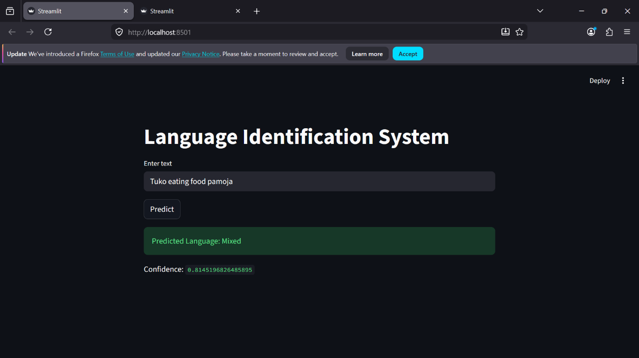
After running streamlit run app.py on terminal
The system interface allows users to input text and receive predicted language along with confidence score. The interface is built using Streamlit and is user-friendly.

CODE STRUCTURE EXPLANATION

Project Structure
- app.py → Streamlit interface
- main.py → model training
- dataset files → training data: 1.

DEPLOYMENT (BONUS)
The application was deployed using Streamlit Cloud.
This allows users to access the system through a web browser without installing any software.
https://language-identifier-project-mgjenzao9fyhagc8besezs.streamlit.app/
Users can:
• Enter text
• Click a prediction button
• View the predicted language instantly
• Get prediction score of the language
The deployment makes the system accessible and user-friendly.
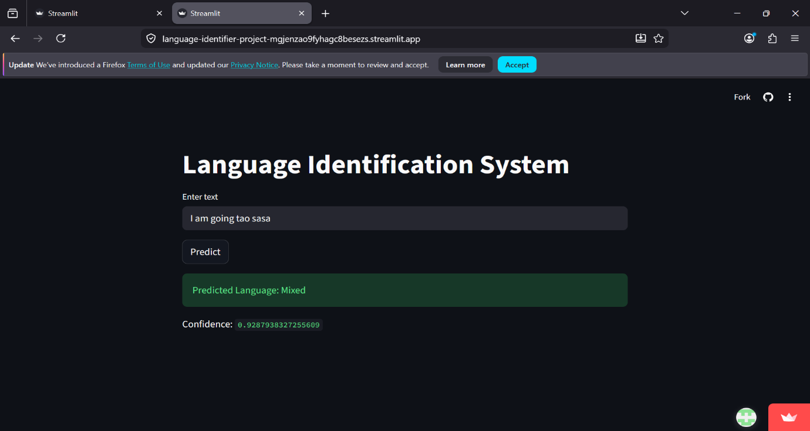

HANDLING MIXED LANGUAGE (BONUS)
A major challenge in language identification is handling code-mixed text.

To address this, a "Mixed" class was introduced in the dataset.

The model was trained using few examples that combine multiple languages, allowing it to recognize hybrid patterns.

This improves the system’s ability to handle real-world communication.

RESULTS
The system achieved very high performance, with accuracy close to 100%.

This indicates that the chosen feature extraction techniques and models are effective for language identification.

However, the high accuracy may also be due to the dataset being relatively simple and controlled.

In real-world scenarios, performance may vary depending on the complexity of input text.

Test Cases
Input test | Expected output | Actual Output
I am going to school | English | English
Ninaenda shule | Swahili | Swahili
Niko base leo | Sheng | Sheng
Ningi thii thukuru | Kikuyu | Kikuyu
Niko going to school leo | Mixed | Mixed

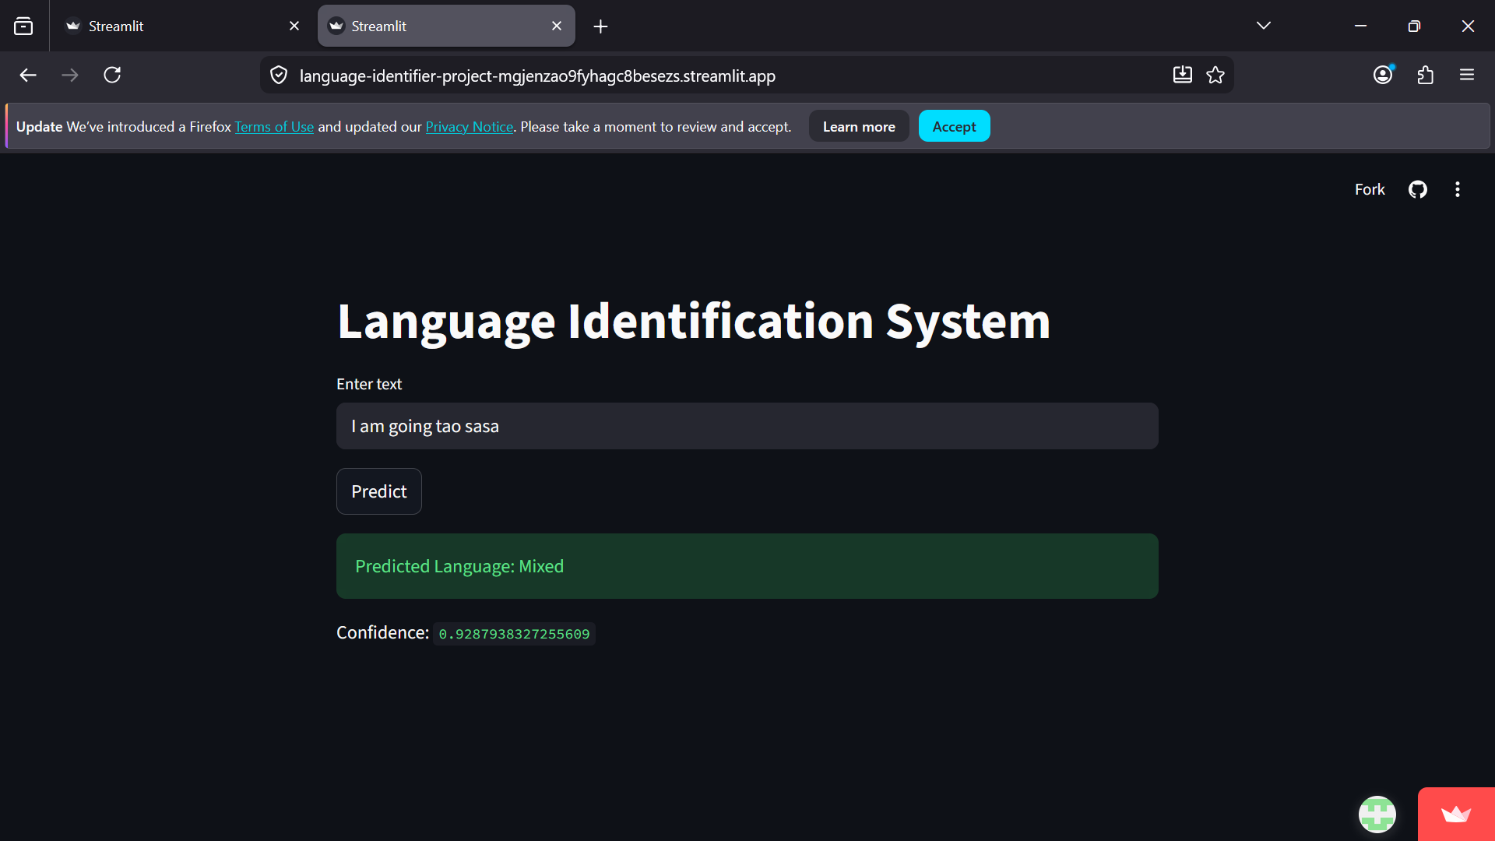

CONCLUSION
This project successfully developed a language identification system capable of handling multiple Kenyan languages and mixed text.

The system demonstrates the effectiveness of machine learning techniques in solving NLP problems.

It also highlights the importance of proper data preparation and feature extraction.

FUTURE WORK
Future improvements can include:

• Using deep learning models such as LSTM or BERT
• Expanding the dataset with more real-world data
• Improving handling of complex mixed-language text
• Deploying the system on larger platforms
• Adding more sub languages of the Kenyan culture and beyond

Limitations
- Performance may drop on very short text
- Unseen slang or new Sheng words may affect accuracy
- Dataset was manually created and may not cover all real-world variations
- Model may struggle with complex mixed-language sentences
- Limited to four main languages

Dataset References
The dataset used in this project was manually created but inspired and guided by real-world language usage patterns from various publicly available sources.
The following references were used to ensure realism and diversity of language:

• Social Media Platforms:
Informal expressions and Sheng slang were inspired by posts and conversations from platforms such as Twitter and Facebook, where code-mixed language is commonly used.

• Online Articles:
Formal English and Swahili sentence structures were influenced by content from:
- BBC News Swahili
- Nation Africa
- Standard Media

• SMS/Text Communication:
Sentence patterns were based on common texting styles used in everyday communication, including abbreviations and informal tone.

• Public Language Datasets:
- Leipzig Corpora Collection (multilingual text data)
- OPUS (Open Parallel Corpus for multilingual text)
- JW300 Dataset (multilingual religious text corpus)

• Transcribed Speech:
Some sentence structures were inspired by spoken language patterns converted into text to simulate real conversations.
These references helped ensure that the dataset reflects realistic usage of English, Swahili, Kikuyu, and Sheng, including mixed-language scenarios.
One limitation is that the dataset was manually created, which may not fully capture all real-world variations.

